# Lab 4: Newton's Second Law and Kinetic Friction

## Our goal in this lab is to investigate how Newton's 2nd Law applies to a sliding object subjected to different forces. In the process we will also estimate the force of force of kinetic friction acting on that object, and compare the result to a direct measurement of that force on the object sliding with no force acting on it.

#### Equipment

You will need the following equipment to complete the lab. If you do not have any of the equipment listed below, please let your instructor know.

* Smartphone or computer with video recording capabilities. Cameras with slow motion capabilities are ideal.
* A way to prop up your phone so that you can take videos of yourself doing things (or another person to help you take videos).
* Computer that runs Vernier Video Analysis (Links to an external site.).
* Some way to measure distances (a ruler or tape measure, for example).
* Two 500 ml plastic bottles.
* A measuring cup, ideally marked in ml. A quarter-cup measuring cup can be used in a pinch.
* Scotch tape or duct tape.
* Dental floss.
* A clear flat surface like a tabletop or desktop that is elevated above the floor.
* Water.

## Pre-Lab

In this lab we will use two 500 ml plastic water bottles. (If you have different sized bottles that may work: ask your instructor). Bottle A will always be filled completely with water: its mass will be fixed. Bottle A will be attached using some dental floss to bottle B, which will contain varying amounts of water. In our experiments we will hang bottle B over the edge of a table and then release it. Some tape will be used to minimize friction between the floss and the table. We will then film bottle A as it slides across the table, and analyze is acceleration using video analysis. The diagram below shows the basic setup.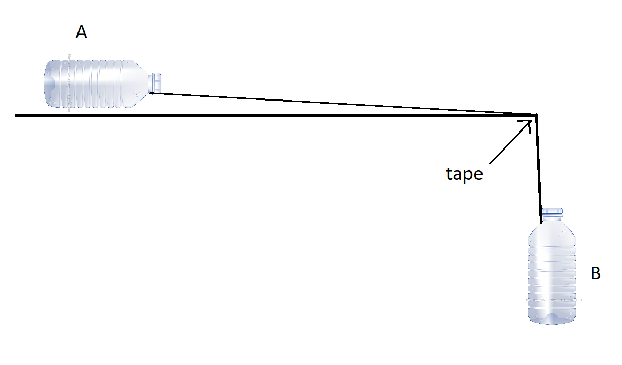

Your task for the prelab will be to take videos of the motion that occurs when you let the bottle fall.

#### Steps for Taking Good Videos

For each video you take below, make sure you to the Following:

* Prior to each recording, measure a distance between two well-separated points that will be in your video that lie in or close to the plane of motion. Record the distance between these two points and mark the two points so that they will be visible in the video.
* The motion of the object should be across the screen, not towards or away from the camera.
* Do not move the camera while the video is being recorded. This is crucial! There is a tendency to try and “track” moving objects with the camera: try to avoid doing this! Propping up the camera rather than holding it is ideal, but you can take good videos by carefully holding the camera steady.
* If possible, use slow-motion filming.
* Use a background that is of a different color than moving object. If the object is dark, use a light background, and vice-versa.
* Caution: with many phones there is a delay after you press the “record” button before filming begins. Hit the “record” button, wait until you see at least one second has elapsed in the recording, and then do the motion.
* Note for iphone 11+ users: the software can't deal with the most recent movie formatting. Before taking your video go to settings/camera and switch your video format to "most compatible".

#### Conducting the Experiment

1. Be sure there is something in the video that can be used as a distance scale. The object you are using as a distance scale should be about as far away from the camera as the bottles will be.
2. Tape a small, dark piece of paper onto bottle A so that it will be easy to track bottle A's motion in the video analysis.
3. Fill bottle A entirely with water: you want there to be no empty space so the water doesn’t “slosh” around in the bottle. For simplicity we will assume that the small amount of water needed to “top off” the bottle is negligible, so we will assume the bottle contains exactly 500 ml of water.
4. Fill bottle B with 250 ml (or, if you can't measure ml, use 1 cup = 237 ml) of water.
5. Using a length of floss or string a couple of feet longer than the height of the table, tie the bottles to each other.
6. Put some tape on the corner of the table so that the floss can slide smoothly over the corner. BE WARNED: some tables may be damaged by applying tape. If this is the case, put some cardboard over the corner of the table, and then apply the tape to the cardboard, and secure the cardboard with the weights.
7. Set up your phone so that it will capture, simultaneously, the bottle sliding across the table and a stopwatch (see below for an example). If you do not have a stopwatch, just google "stopwatch" on your computer and film your computer screen. The stopwatch will be sued to accurately measure the frame rate your camera is using. 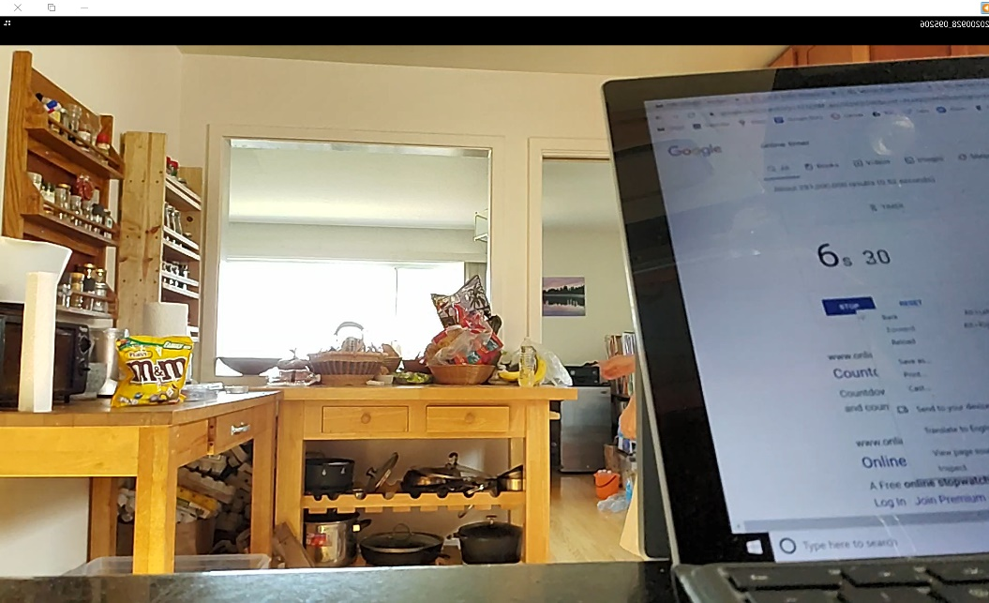
8. Start the stopwatch. Start filming (slow-motion if possible) and the hold bottle A so that the floss runs over the corner of the table and bottle B is hanging near the top of the table, but not actually touching the top of the table. Release bottle A so that bottle B falls down and drags bottle A horizontally across the table. (Be sure to do this by holding and releasing bottle A: if you hold and release bottle B you can get jerky motion).
9. Add 62.5 ml more water (or 1/4 cup =59 ml) to bottle B and repeat the experiment. Do this three more times (for a total of five trials), so that on your last trial bottle B has 500 ml of water in it.
10. Finally, detach bottle A from the string and take a video of bottle A sliding across the same surface: just give it a short push and then let it slide. (The goal here is to measure the acceleration due to friction only).

#### Video Tracking

Use [Vernier Video Analysis](https://videoanalysis.app/?key=4020e622e6bf436db560eca482f462fb-86ac98513bde5c09cf97fbdc4193ace1-0aa757b14dd396b9d5335332eac63844-d665c75f31e7d685fb4718404e004ev2) to estimate the acceleration that occurs in each motion. You can find the acceleration by finding the slope of a linear fit on the x-velocity vs. time graph: please do not use other methods to get the acceleration. As you do the video analysis, don’t forget the following:

* Establish a distance scale.
* Finding the correct frame rate is very important. If you used slow motion, on some phones the frame rate is likely either 120 frames per second (fps) or 240 fps, however on other phones, the video itself will be slowed, so the effective frame rate may be 30 or 60 fps. Use the images of the stopwatch to verify what frame rate your camera is using, and enter that into the Video Analysis software.
* For all motions, you want the acceleration for only the part of the motion A) after bottle A left your hand and B) before bottle B hits the floor. When you do your linear fit, only include this data and exclude the rest of the data: **basically, you should only be fitting data that is clearly part of a straight line on the v vs. t graph**.

1. Take a screen capture of your v s. t graph with the best fit line shown for each experiment.

## Live (Synchronous) Lab

#### Analyzing the System with Newton’s Second Law

Now we’ll develop a theoretical understanding of this motion. For our analysis, we’ll consider a moment in time when bottle A is already in the process of sliding to the right and bottle B is already moving downwards.

1. Collaborating with your group, draw free body diagrams for both bottles, using subscripts to properly label forces. (For example $\vec{w_{EA}}$ is the weight of the Earth acting on bottle A). Assume friction between the floss and the table is negligible, but DO include kinetic friction between bottle A and the table. Use subscripts, and use the abbreviations A, for bottle A, B for bottle B, F for the floss, T for the table, and E for the earth.

Newton's Second Law Tells us:

$$F_{net,A,x}=m_{A}a_{A,x}$$

$$F_{net,A,y}=m_{A}a_{A,y}$$

$$F_{net,B,y}=m_{B}a_{B,y}$$

(We skip the x-component for bottle B, because there are no horizontal forces on bottle B).

1. Using your FBDs, replace each “ $F_{net}$” above with the forces acting on that object in that direction. If a force acts in the negative direction, include a negative sign in front of it. Your result should be three equations.
2. What is $a_{A,y}$? How do we know? What does this tell us about the magnitude of the normal force acting on bottle A?
3. What is the relationship between $a_{A,x}$ and $a_{B,y}$? How do you know? Think carefully about the signs: if $a_{A,x}$ is positive, what is the sign of $a_{B,y}$?
4. Using your answers above, find $f_{k,TA}$ in terms of $m_{A}$, $m_{B}$, $a_{A,x}$, and $g$. You can do this by combining the equations from Q2 and Q4, and noting that the tension in the floss will be the same on both ends of the floss. Show your work on your paper.

#### Calculating Kinetic Friction from Your Data

1. Using Excel or Google Sheets, the accelerations you measured in the prelab, along with the amounts of water in each bottle to calculate, for each trial (except the one where bottle A slides by itself), the force of friction. Note that 1 ml of water has a mass of 1 g (don’t forget to convert to kg)! You can neglect the mass of the empty bottles and the floss/string. Also calculate the average of your friction force measurements, discarding any clear outliers. Show an image of the table you created in your GradeScope document: be sure to label the columns clearly in your table.
2. Using the average force of kinetic friction you measured above, calculate the expected acceleration of bottle A under the influence of kinetic friction only. Compare your results to the acceleration you measured in the video with bottle A sliding by itself, and calculate the percent discrepancy using the equation:

$$\% discrepancy=\frac{Experiment-Theory}{Theory}*100$$

Here, we'll treat the "experimental" acceleration to be the acceleration you predicted from your five measurements with bottle B, and the "theory" value to be the one directly measured by observing bottle A sliding alone. Show your work in your GradeScope document.

1. Using your average value for the force of kinetic friction and your answer to Q3, calculate the coefficient of kinetic friction between bottle A and the table using the equation $f_{k}=µ_{k}n$. Show your work in your GradeScope document.